AI-Powered Customer Support Chatbot

This customer support chatbot, powered by AI, will automatically respond to Frequently Asked Questions (FAQs), order questions, and password issues, as well as create a ticket and -- if necessary -- pass on more complicated questions to a human agent. It uses external services (Order API, Email, and Ticketing System) to provide support promptly.

Use Case Diagram

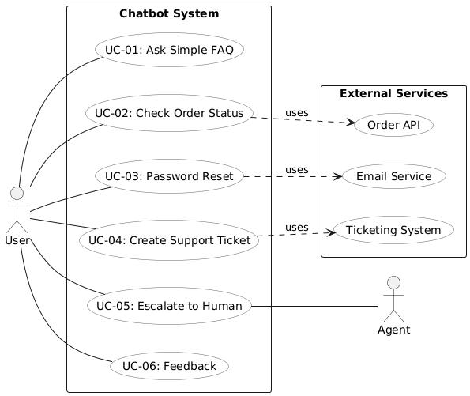

Prototypes

1.Main Page

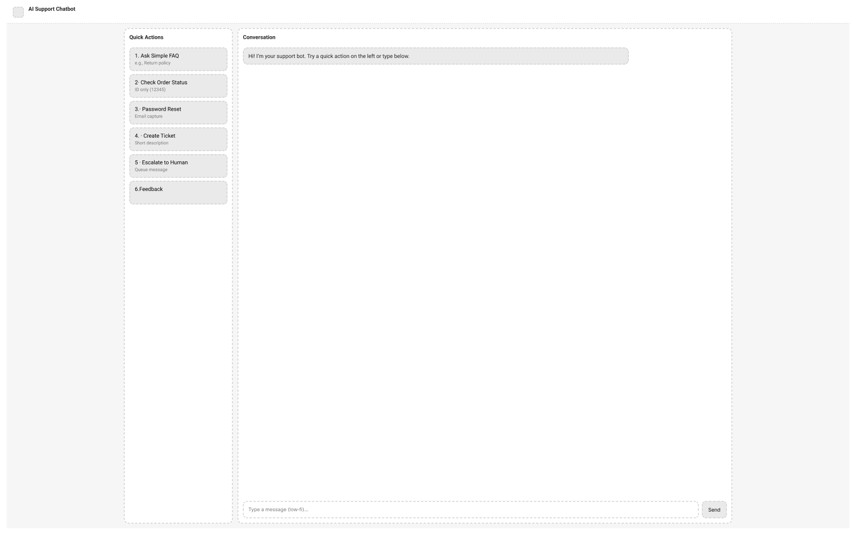

2.Main Page → Ask simple FAQS

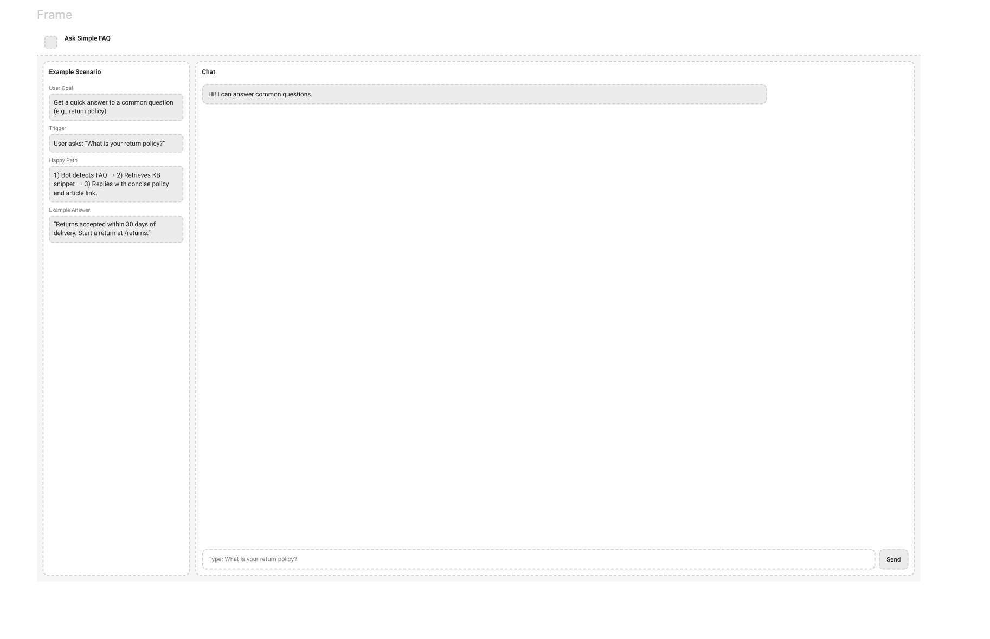3.Main Page → Check order Status
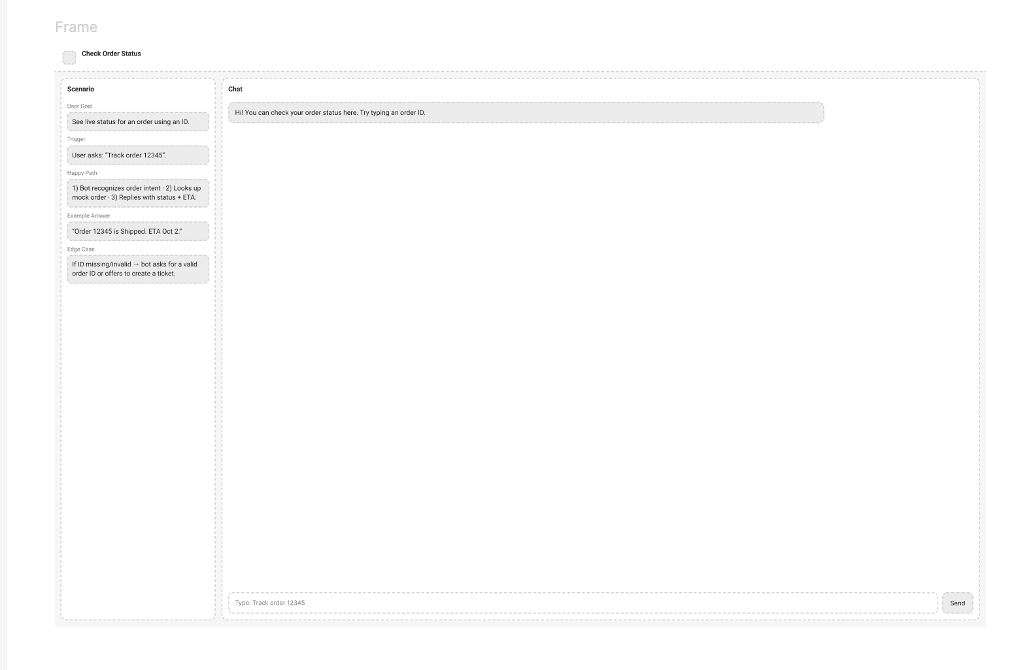
4, Main Page → Password Reset
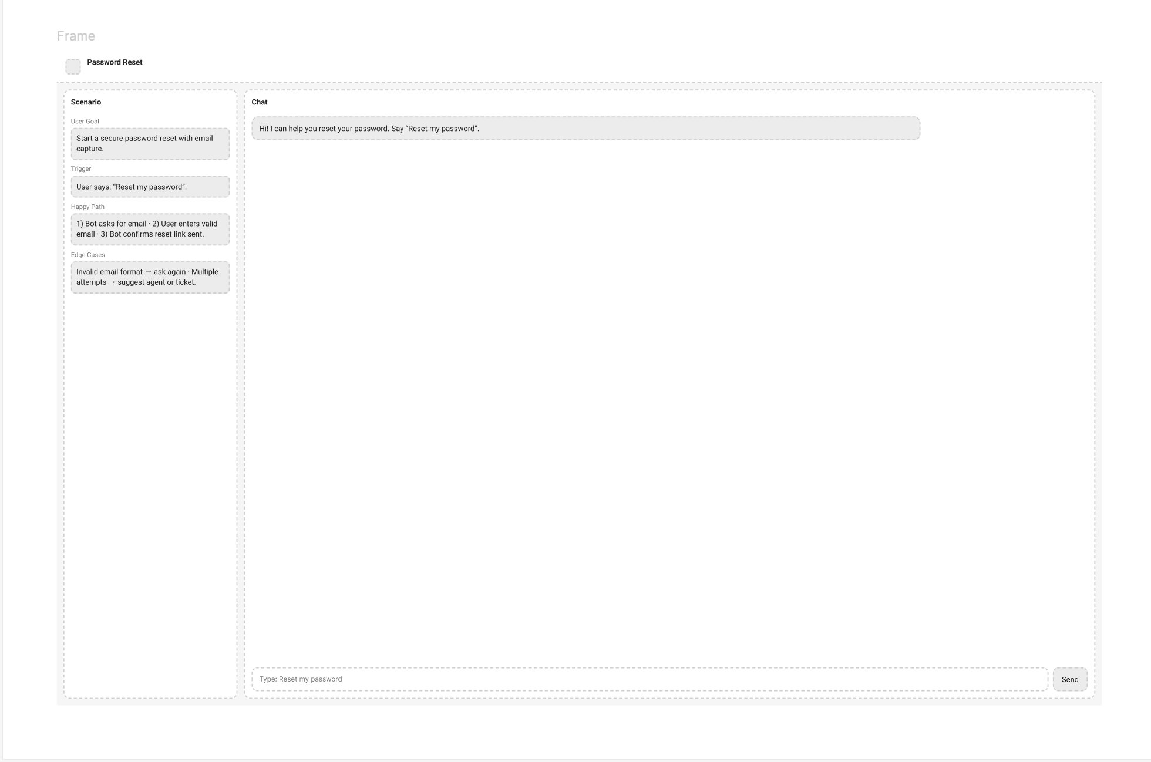
5. Main Page→ Support Ticket
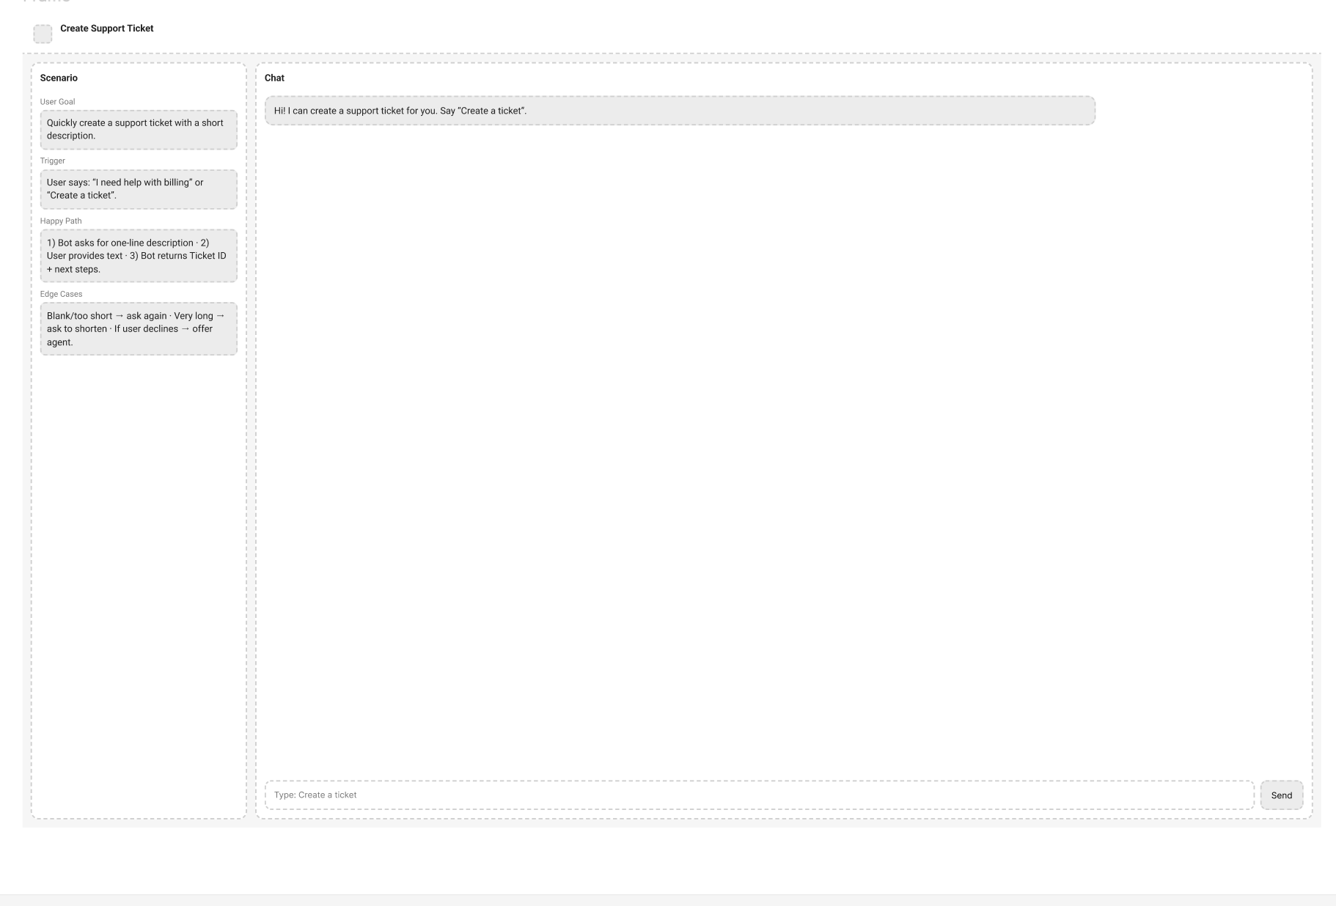

6.Main Page →Escalate to human
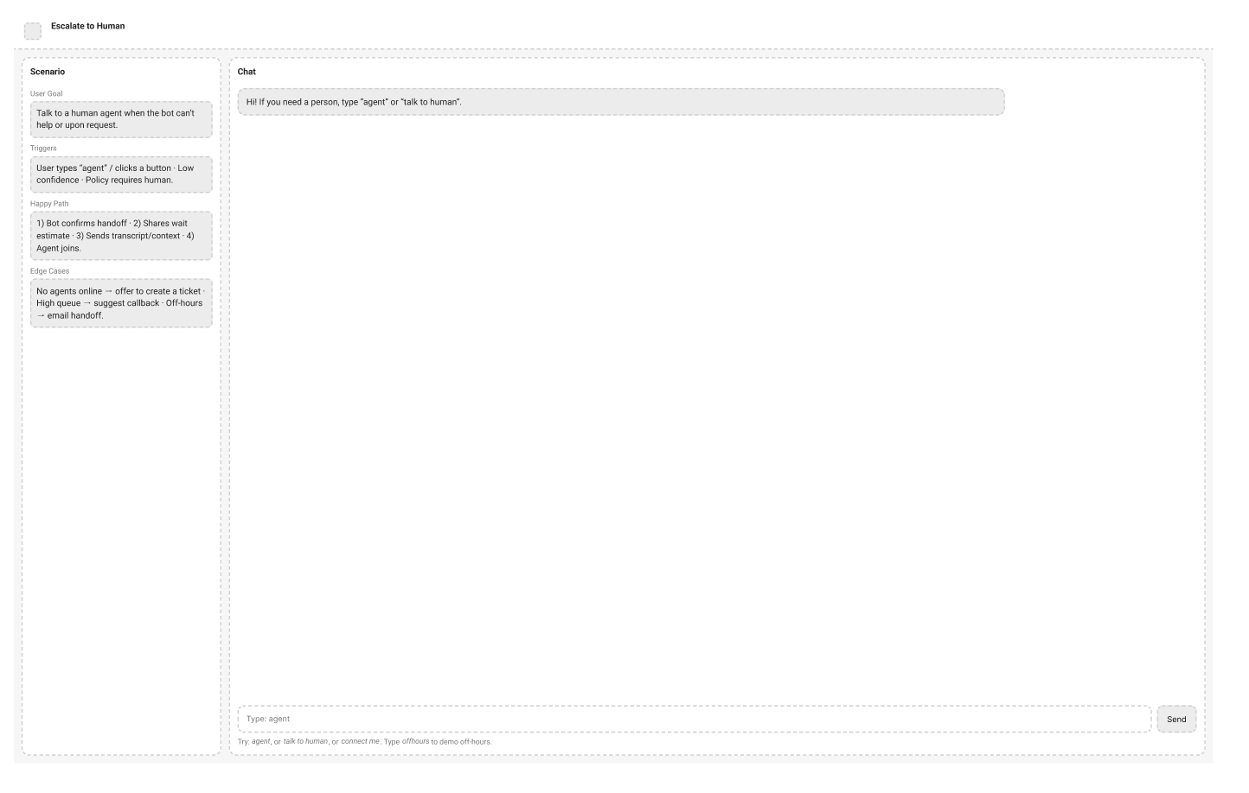
7.Main Page → Feedback
